Lost Worlds of scholarship and printing: The John Van Sickle Book Donation
Aldus Manutius (1449-1515) [et al.]. Πινδαρου Ολύμπια; Πύθια; Νέμεα; Ἴσθμια. Καλλιμάχου Ὕμνοι, οἱ εὑρισκόμενοι. Διονυσίου περιήγησις. Λυκώφρονος Ἀλεξάνδρα, τὸ σκοτεινὸν ποιήμα : Pindari Olympia; Pythia; Nemea; Isthmia. Callimachi hymni qui inueniuntur. Dionysius De situ orbis. Licophronis Alexandra, obscurum poema (Venice, 1513).
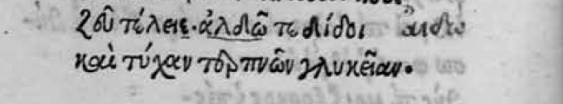
Henricus Stephanus (d. 1598) [ed.], Ἀνακρέοντος Τεΐου Μέλη : Anacreontis Teij Odae (Lutetiae: Apud Henricum Stephanum, 1554).
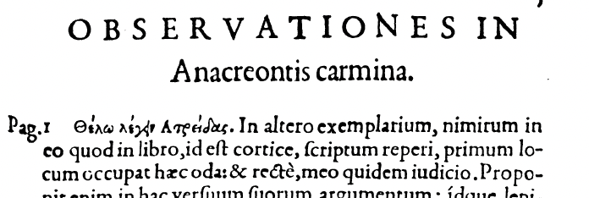
Aristotelis ad Nicomachum filium libri decem (Florence, 1547)

Therefore, I healed their wounds, as far as I could; and I took care that they would be printed much more correctly, without the many errors that disfigured them. I have restored to the text not few words and whole sentences that were missing, I then removed from a place that did not belong to them, what were once scholia or notes and had inappropriately, crept into the text. I also corrected many words that were incomprehensible.

Pier Vettori, Commentarii in tres libros Aristotelis De arte dicendi, positis ante singulas declarationes graecis verbis auctoris (Fkorence, 1548)

I also used another help that was not to be despised; I have in fact carefully studied an old [Latin] translation. From reading it I was able to understand what the author of the translation read in his Greek manuscript. The translator [William of Moerbeke] was clearly a barbarian devoid of all cultural refinement; yet he did his work conscientiously; so much so that, while I held that barbarous translation in my hands, it seemed to me to have the same as having the Greek manuscript and to hear the words of its speech. The translator in fact never even changes the word order, he translates literally and frequently even uses Greek words when he does not understand their meaning, or when he does not see how to make a word with another word. Moreover, since the translation is of many centuries ago, it is necessary to consider that then the manuscripts were less incomplete and more correct. I therefore found that translation often in agreement with that excellent manuscript of which I spoke above].
Vettori comments on Rhetoric 3.2.4: We must see to it that our devices are not understood by those to whom we are speaking, but that we seem to be following nature. If we manage this, we will find it easy to win their belief. For as this has great persuasive power, so the alternative, when we are seen to be speaking artfully, has one, or rather prevents the winning of belief, and the audience is completely alienated as it listens.

Pier Vettori, Commentarii in primum librum Aristotelis de Arte poetica (Florence, 1560)

Aristotle Poetics 1: Epic poetry and Tragedy, Comedy also and Dithyrambic: poetry, and the music of the flute and of the lyre in most of their forms, are all in their general conception modes of imitation. They differ, however, from one: another in [the manner of imitation] . . . in the arts above mentioned, taken as a whole, the imitation is produced by rhythm, language, or 'harmony,' either singly or combined. Thus in the music of the flute and of the lyre, 'harmony' and rhythm alone are employed; also in other arts, such as that of the shepherd's pipe, which are essentially similar to these. In dancing, rhythm alone is used without 'harmony'; for even dancing imitates character, emotion, and action, by rhythmical movement.

Aristotle, Poetics 1460 a 12-14 as read in the MSS and in early editions:: δεῖ μὲν οὖν ἐν ταῖς τραγῳδίαις ποιεῖν τὸ θαυμαστόν, μᾶλλον δ’ ἐνδέχεται ἐν τῇ ἐποποιίᾳ τὸ ἀνάλογον. In tragedy one must create a sense of wonder, but epic has more scope for it by proportion.

Vettori: I read alogon and not analogon, as appears in print, since this word can in no way be in this place; however, the one I have restored, alogon, fits so marvelously into the passage, which is why, serving the coherence of the sense, I have dared to emend [the text] in this way.”
Vettori’s translation: Oportet quidem igitur in tragoedijs facere admirabile magis autem contingit in epopeia quod ratione caret (to alogon) (. . . epic has more scope for the irrational)\

BNF Paris MS gr. 1750, colophon (Plutarch, Life of Cicero:

